September 23, 2018

Ana Slocum - S00615504

IT2320 Lab 4

CRN 82936

# Screenshots

1. Start Quiz

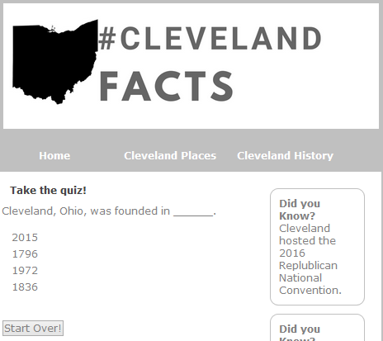

2. Select Answer

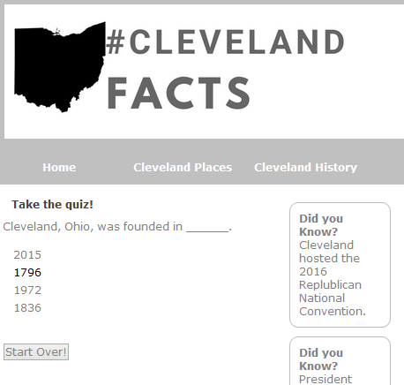

3. It shows “Correct” or “Incorrect” depending on how the question is answered.

4. Finish Quiz; Check Score.

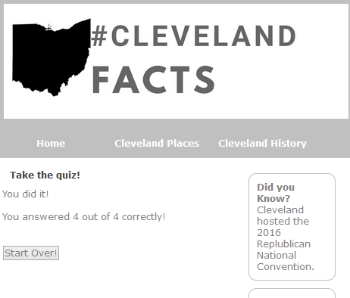

# GitHUB Commit ID

d36dc59

d36dc59a92dac0887b6a2b145b45696b3f9716d8